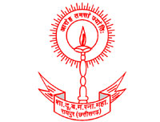

Workshop
On
Personality Development Program
By
By Shubhra Johri

Workshop related to personality development of departmental students to groom their way to present themselves in various fields. The aim to organize this workshop is to aware them about the importance of personality along with their subject knowledge. It is decided to continue this personality development online program so that it covers all the aspects of personality grooming like body language, way of expressing their point of view in a group of people and many more things.
The online workshop started at 12:00a.m. First of all the coordinator of program Dr. Ragini Pandey had given introduction of the program Then Principal Dr. Shraddha Girolkar addressed the participants and told the importance of the program. This online session was interactive and got very positive and effective response from all the students.
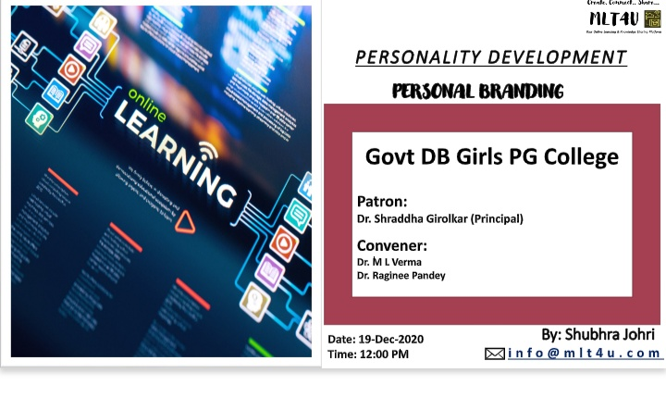
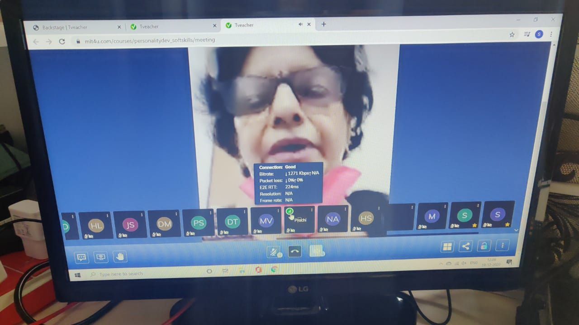

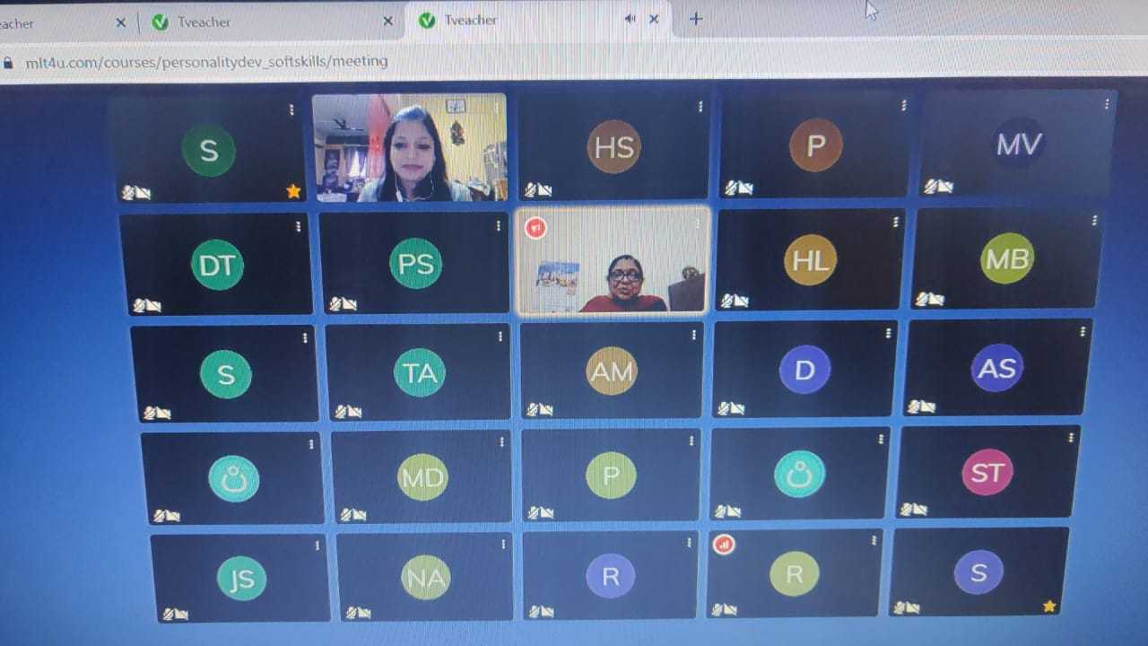
This workshop will be continued for the students of post graduate class this session.

