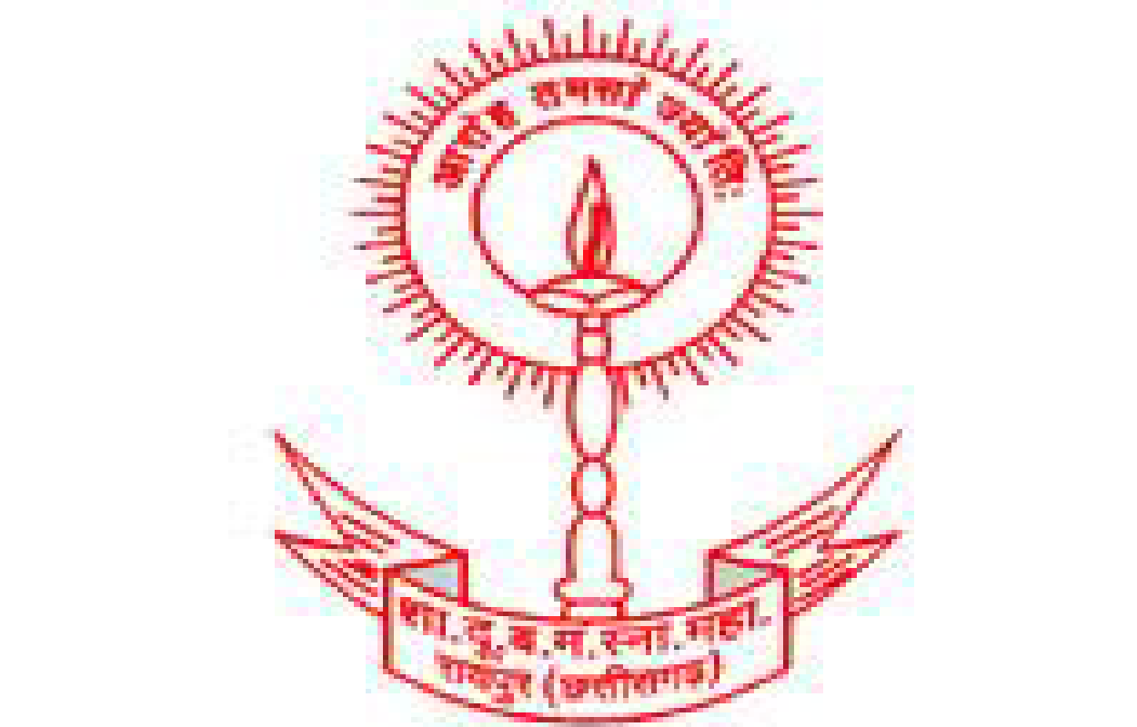
Govt. D.B. Girls' P.G. College, Raipur- 492001 (C.G.)
(An Autonomous College, affiliated to Pt. Ravishankar Shukla University, Raipur (C.G.)
Tel. 0771-2229248, email-dbgirls@yahoo.co.in, dbgirlspgraipur@gmail.com
website - www.dbgirls.org

A Report
Event Organized during 2019-20

Name of the Department: IQAC

Name/Title of the event: National Workshop on Operation and Maintenance of Opto Analytical
Laboratory Equipments (NWOMOLE, 2020)

Name of Collaborative Agency (if any): Western Regional Instrumentation Centre, Mumbai
(National Facility Centre for Instrumentation of UGC, New Delhi)

Date of the event (From-To): 06.01.2020 -10.01.2020

Level of the event (Department/College/State/National/International): National

Nature of event (in Collaboration or independent): In collaboration with WRIC, Mumbai

Name of the Coordinator/Convener/Organizing Secretary) of the event: Dr. Maya Shedpure
Dr. M.L. Verma

Name of the organizing committee members: Dr. Ragini Pandey, Dr. Richa Tikariha,
Dr. Neetu Harmukh, Dr. Bhupendra Sen, Dr. Kiran Dewangan

Name of the Experts: Mr. K.K. Mahajan, Mr. NN Rao, Ms. Sunita Batra, Mr. Sudhir Kumar,
Mr. Milind Shidruk and Mr. Devendra Gunde from WRIC Mumbai.

Objective of the event: The motive behind organizing this workshop is the fact that most of the faculties/technicians in colleges are not trained adequately on the repair/maintenance of laboratory equipment abandoned due to very minor issues, which can be easily attended with little orientation about their proper upkeep and maintenance. Further, due to inadequate knowledge the money spent on repairs and maintenance of these equipment is large which can be avoidable to a great extent and also save the unnecessary long lead time for repairs. This will smoothen the functioning of laboratories and our students will be the biggest beneficiary of the same.

Number of participants: 47

Outcome of the event: The program curriculum has been specifically designed for technical and scientific staff of science departments of the college. The program aimed at imparting skills in operation, maintenance and repairs of laboratory instruments commonly used in science laboratories i.e. Physics, Chemistry and Biological Sciences.
Following activities have been carried out during the workshop by the lectures from WRIC experts followed by hands on training programme
- Introduction to the basics of electric and electronic equipment and components.
- Awareness and requirement of general repairs and maintenance of laboratory instruments.
- Repairing of electrical instruments like, hot plate, heating mantle, magnetic stirrer and water bath.
- Working, proper handling and repairing of temperature controlled oven, incubator and water bath.
- Working principle, repairing, maintenance and calibration of pH meter, pH electrode, colorimeters, flame photometer, spectrophotometer, conductivity meter, cell counter, cryostat, deep freeze, laminar flow, flame photometer, UV spectrophotometer.
- Operation, repairing and maintenance of optical Microscope and analytical balance.
- Working principle and repairing of electronic instruments, like transistors, Op. amplifier, LCR circuit, rectifier circuit etc.
All the lectures delivered by the experts from WRIC, Mumbai were very nice and played a significant role in understanding the working of various laboratory instruments. In addition, hands-on training during the lab session was the most important and beneficial part of the workshop for all the participants. During the lab sessions of this 5 day workshop, about 158 instruments from different laboratories got repaired with the help of learned, skilled experts from WRIC, Mumbai. In fact, every participant gets amazed to know that most of these instruments were not in use due to very minor defects and can be solved easily. It was a historical event organized in this college and a golden opportunity for all the participants of the workshop.

Event photographs:

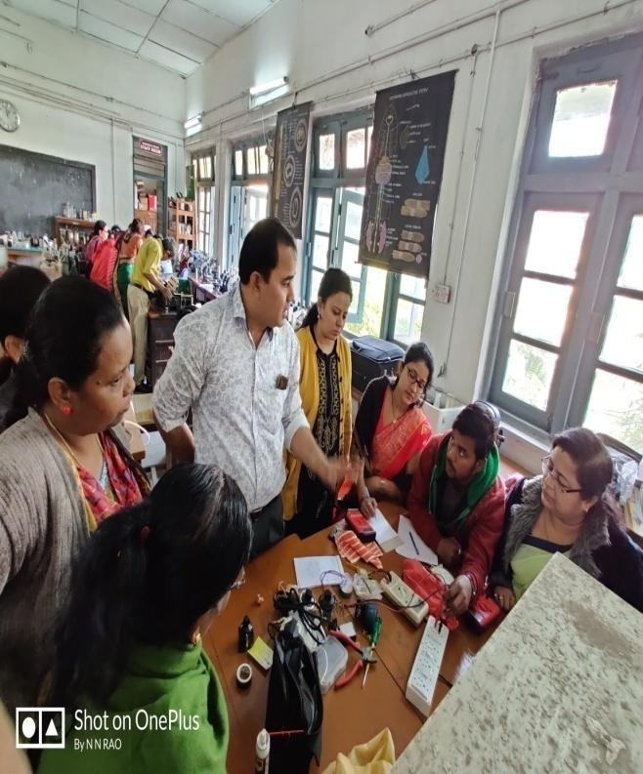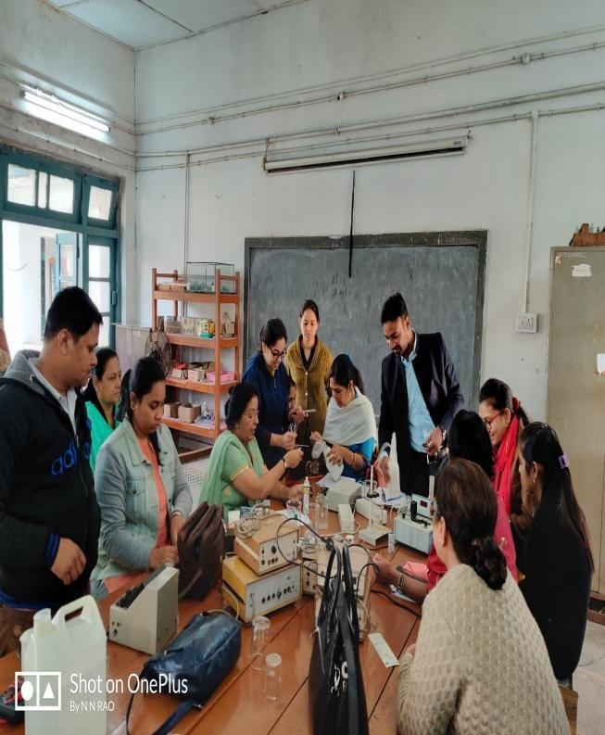
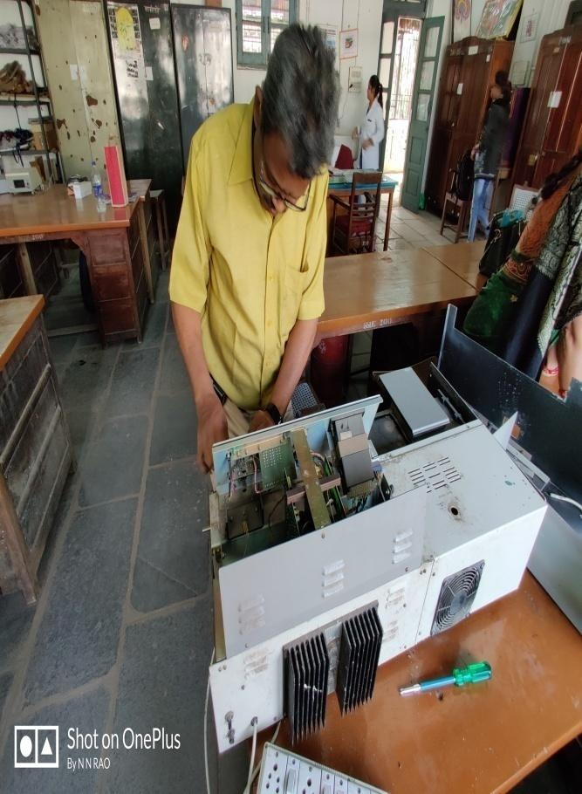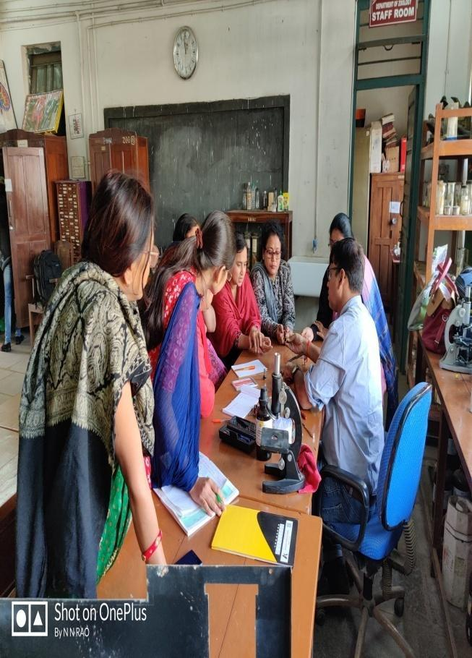

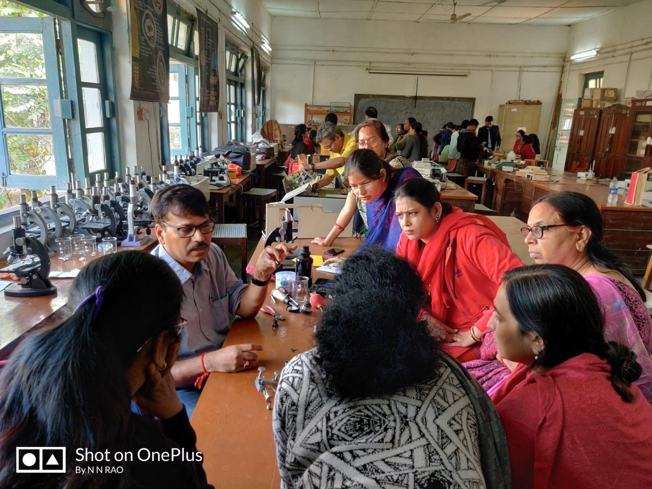

Feedback from participants:

From the verbal feedback, participants expressed their views and appreciated the efforts taken by the organizing committe and experts from WRIC to make this workshop successful and memorable.The participants were very much happy about the overall hospitality and most importantly the activities of the workshop. Everyone expressed that they are benefitted like they could interact with the experts and learn the easy operation, maintenance and repair of various laboratory instruments.

Brochure of the event: Please see below

Signature of Coordinator Signature of Principal

About the host institution  Established in 1958, Govt. D.B. Girls’ P.G. (Autonomous) College, Raipur is affiliated to Pt. Ravishankar, Shukla University and ranks among the most reputed colleges of the state, accredited with ‘B’ grade by NAAC. The college received autonomous status in the year 1989. It is also recognized as Centre with Potential for Excellence, Community College Scheme, Center for Women Studies, Sugamaya Bharat Abhiyan etc. by UGC.  About WRIC  Western Regional Instrumentation Centre (WRIC), Mumbai is an autonomous institute established in 1977 and fully funded by the University Grants Commission (UGC), Government of India, New Delhi in association with University of Mumbai. WRIC is the only Regional Instrumentation Centre in India and which has now been recognized as a National Facility Centre for Instrumentation by UGC.  The overall impact of the Centre’s activities since its inception has been to further the UGC’s efforts in creating adequate, self-supporting infrastructure in the Indian universities by providing research, maintenance, testing and measurement services in the field of instrumentation  WRIC aims to be:  •Resource Centre to create necessary facilities for Instrumentation programmes.  •Role model for providing instrument services such as calibration (Electro technical, temperature and pressure), Repair and maintenance, Glass blowing, Instrument fabrication services, organizing Maintenance camps  •Centre for Design and Development of new teaching aids to facilitate teaching, research  •Resource Centre for conducting training programmes in instrumentation and instruments repair and maintenance  •Resource centre for R&D in instrumentation for Education, Research and Industries. | Organizing Committee  Chief Patron  Hon’ble Dr. Keshrilal Verma  Vice Chancellor,  Pt. Ravishankar Shukla University,  Raipur-492010  Co-chair  Dr. J.N. Verma  Principal  Govt. D.B. Girls’ P.G. (Autonomous) College, Raipur-492001  Ph. No.: 91(0771)2229248  Fax: 91(0771)2229248  E-Mail: dbgirls@yahoo.co.in  Dr. Indu A. George  Director  WRIC  University of Mumbai  Vidyanagari  Kalina, Santacruz (E)  Mumbai – 400 098  Telefax. : 022-2653 0248  E-mail :director@wric.mu.ac.in  Program Co-ordinator Course Co-ordinator  Mr. K. K.Mahajan Mr. N.Nageswara Rao  Technical Officer III Technical officer I  Organizing Secretary  Dr. Maya Shedpure, Professor in Zoology  Dr. M.L. Verma , Professor in Physics  Technical Resource Persons from WRIC  K.K.Mahajan, N. Nageswara Rao  Sunita Batra , Sudhir Kumar ,  Milind Shidruk , Devendra Gunde  Local Organizing Committee Members  Dr.Ragini Pandey, Dr. Richa Tikariha, Dr. Neetu Harmukh, Dr. Bhupendra Sen, Dr. Kiran Dewangan | Govt D.B. Girls’ P.G. (Autonomous ) College, Raipur-492001  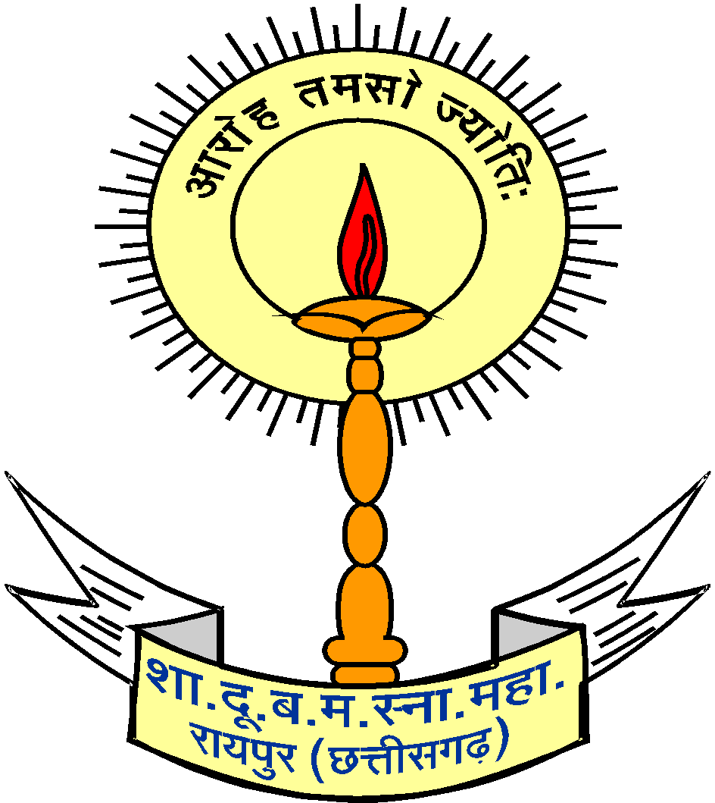  National Workshop  On  “Operation and Maintenance of Opto Analytical Laboratory Equipments”  (NWOMOLE, 2020)  6–10 January, 2020  in association with  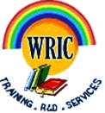  Western Regional Instrumentation  Centre, Mumbai.  (National Facility Centre for Instrumentation  of  UGC, New Delhi)  TEL.NO. +91(0771)2229248  +91 (2352) 230086 / 230088  FAX: +91(0771)2229248  +91 (2352) 230044  E-MAIL: dbgirls@yahoo.co.in  Website: www.dbgirls.org  www.wric.ac.in
Dear Sir/Madam,  Govt. D.B. Girls’ P.G. (Autonomous) College, Raipur in association with UGC's Western Regional Instrumentation Centre, Mumbai, is organizing a Five day National Workshop on “Operation and Maintenance of Opto Analytical Laboratory Equipments” from 6–10 January, 2020. The keen motivation behind organizing this programme is the fact that most of the faculties/ technicians in colleges are not trained adequately on the repair/maintenance of electronic equipments. Many laboratories have a large number of equipments abandoned due to very minor defects. Also, the money that is spent for the repair and maintenance of these equipments is very large. Again, the repairing cannot be performed in time leading to several difficulties in the smooth functioning of laboratories. In a separate dimension, the wastes emerging from electronic equipments is alarming and is going to be a great challenge for the present scientific community. The workshop focuses on these issues.  The training will be given on the essential equipments of any B.Sc. or M.Sc. laboratories like Analytical Electrical and optical Instruments etc. The participants are welcome to bring their electronic equipments (Only one or two equipments) from their laboratories that needs repair.  Scope:  The program curriculum has been specifically designed for technical and scientific staff of science departments of Higher Education Institute. This program aims at imparting skills in operation, maintenance and repairs of laboratory instruments commonly used in science laboratories.  Physics, Chemistry and Biological Sciences  - Introduction to the basic of electric and electronic  equipments and components.  - Awareness and requirement of general repairs and maintenance of laboratory instruments. | - Repairing of electrical instruments like, hot plate, heating mantel, magnetic stirrer and water bath.  - Working, proper handling and repairing of temperature controlled oven, incubator and water bath.  - Working principle repairing, maintenance and calibration of pH meter, pH electrode, colorimeters, flame photometer, spectrophotometer and conductivity meter .  - Operation, repairing and maintenance of optical Microscope and analytical balance.  Maximum number of participants : 30  Note : Colleges may send their Instruments for repairing with their participants  Registration Fees - Rs 1500/- (For Teaching faculty)  Rs 1000/- (For Lab Technicians)  Rs 800/- (For Research scholars)  The registration fee can be paid through DD/Cheque /cash  in favour of Principal, Govt D.B. Girls’ P.G. College , Raipur .  Accommodation can be arranged on request from participants with additional charges.  Important Dates :  Last date for registration: 31.12.2019  Last date for accommodation request: 31.12.2019  Contact numbers:  Dr. Maya Shedpure, 9300202444  Dr. M.L. Verma, 9407624835  Dr. Raginee Pandey, 9425213726  Dr. Richa Tikariha, 9301819000  Dr. Neetu Harmukh, 9406241909  Dr. Bhupendra Sen, 9098710075  Dr. Kiran Dewangan, 9907144122 | APPLICATION PROFORMA  National Workshop on Operation and Maintenance of Opto Analytical Laboratory Equipments  (6–10 January, 2020)  Name and Designation of Applicant :  ______________________________________________________________________________  ______________________________________________________________________________  Correspondence Address :  ______________________________________________________________________________  Tel. (Res.)_______________________ (Off.) __________________________________  (Mob.)____________________________(Fax) _________________________________  E-mail _________________________  Age __________________________  Educational and Professional Qualification :_____________________________  Nature of Present Job :___________________________________________________  Sponsoring Department/College :____________________________________  D.D./Cheque No. ___________________dated ________________________________  Drawn on ________________________________________________________________  for ` _____________________ or cash _____________________  Signature of the Candidate ____________________________________________  If selected Prof./Dr./Mr./Ms. __________________________________________  will be relived to join the workshop/training programme  Recommendation of Head/Principal/Director of  Department/College/Institute

